Key Issue 6.1: Where Are Religions Distributed?
Pages 186-197
- Label the religions and percents. How many people are estimated to practice the four largest?

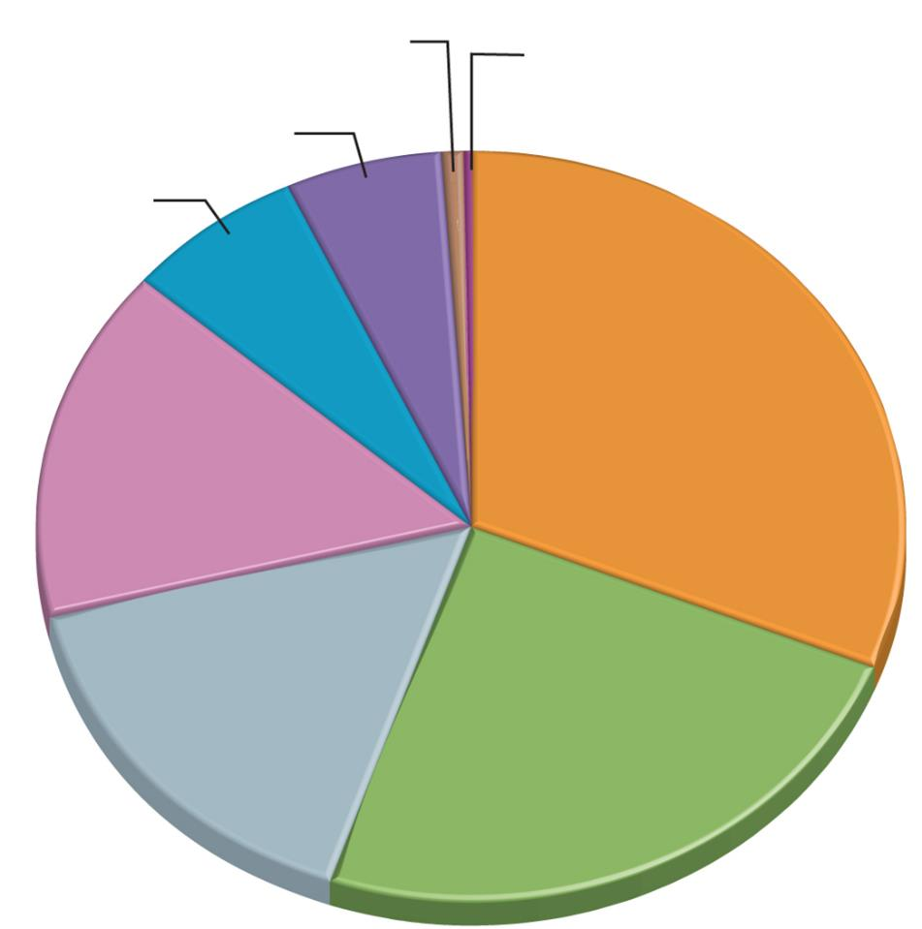
Christianity=
Islam=
Hinduism=
Buddhism=

- Define atheism:

- Define agnosticism:

- Define universalizing religion:

- Define ethnic religion:

- When analyzing the map on pg. 188 (figure 6.5), what are some of the issues with the data?

- Give the percentage of the world’s Christian population belonging to each of Christianity’s three major branches.

- What percentage of Latin Americans are Roman Catholic?

- Protestants comprise what percentage of North Americans? List the five largest denominations.

- Complete this chart dividing Buddhism into its three main branches.

Branch | % of Global Buddhist Population | Regions of Predominance

- Why are Buddhists difficult to count?

- What do the Arabic words “Islam” and “Muslim” translate to in English?

- Half of the world’s Muslims live in the Middle East. The other half live in four countries outside the Middle East. Name them.

- Give the percentage of each of Islam’s two greatest branches: Sunni & Shiite (Shia).

- Only in six countries do Shiite Muslims number more than Sunni. What are they?

- Where are Hindus concentrated? What percent of all Hindus live there?

- Where are most of the rest?

- Make a note or two (that seem of geographic interest) about each of the following ethnic religion listed below.
  - Primal-Indigenous:

  - Confucianism:

  - Taoism:

  - Animism:

  - Sikhism:

  - Judaism:

  - Shinto:

Key Issue 6.2: Why Do Religions Have Distintive Distributions?
Pages 198-207
- Complete the chart below describing the origins and branches of the major universalizing religions.
 | Christianity | Islam | Buddhism
Year of Origin
Founder
Major Branches & Main Belief of Each Branch

- Buddhism is built around “Four Noble Truths” as taught by the Buddha. Summarize them.

- How was the origin of Hinduism different than universalizing religions?

- When did it originate?

- Where did it originate?

- What two ancient peoples beliefs blended to form Hinduism?

- Give two reasons for the expansion of Buddhism.

- Give three ways in which Islam spread.

- Give three explanations for the diffusion of Christianity.

- What are the three main regions that Christians are migrating from? Two regions that are their destination?

- What region is the main destination for Islamic migrants? What specific countries are the primary destinations and what are their countries of origin?

- How is Judaism’s distribution very different from other ethnic religions? What main regions are home to most Jews?

- What was the diaspora?

- How were most Jews treated as they lived among other nationalities?

- What is the origin of the term ghetto?

Key Issue 6.3: Why Do Religions Organize Space in Specific Patterns?
Pages 208-219
- In what two ways do religious structures often stand out in a landscape?

- For Christianity, what two reasons does a church, the physical structure, play a more critical role than in other religions?

- Why do many Christian churches vary in architectural style?

- How is a Muslim mosque viewed differently than a Christian church?

- What is the religious purpose of a Buddhist pagoda?

- How was pilgrimage a part of the development of pagodas?

- Formal worship in a pagoda is not typical. Where does it usually take place?

- How are Hindu temples different than both churches and mosques?

- What is a pilgrimage?

- Describe the importance of pilgrimage for Islam and for Buddhism.
Islam Buddhism

- Complete the chart below with brief notes on the religious settlements indicated.
Utopian Settlements
Salt Lake City, Utah
Puritans

- Describe an autonomous religion:

- In the absence of a hierarchy, what is the only formal organization of territory in Islam?

- What holds Islam together?

- Complete the chart below to categorize other religions and denominations.
Autonomous Religions | Hierarchical Religions
- Define hierarchical religion:

- List the Roman Catholic hierarchy, indicating geographic region and leader who heads it.

- Why are parishes in Latin America so much larger than in Europe?

- Give at least three examples of how religions have incorporated characteristics of cosmology.

- Christian practice burial of the dead. Complete the flow chart below to indicate the history of this practice.
⬇
⬇

- Complete the chart below with brief notes on the disposal of the dead in ways other than burial.
Hindus
Parsis
Micronesia
- Complete the chart below regarding religious calendars.
What is the most prominent feature of the calendar in an ethnic religion? | What is the principle purpose of the calendar in a universalizing religion?

- How is the Islamic calendar typical of the ethnic use of the calendar?

- Both the Jewish and the Muslims use a lunar calendar, yet in a different way and with very different results. Explain.

- How is the date of Easter related to physical geography (the natural world) through the calendar?

- Why do different Christian branches celebrate Easter on different days?

- How is this similar to Buddhism’s major holidays?

- What is the significance of the solstice?

Key Issue 6.4: Why Do Territorial Conflicts Arise Among Religious Groups?
Pages 220-226
- Define fundamentalism:

- What aspect of Hinduism has clashed with Western/modern ideas?

- What western groups criticized this aspect? Why?

- How has the Indian government responded to this issue?

- In Russia/Soviet Union, how did each of the following attempt to limit the influence of religion, specifically the Eastern Orthodox Church?
Czar Peter the Great:

Communism:

- What happened, and is continuing to happen, in each of the following regions of the Russian Empire/Soviet Union since the fall of Communism in the 1990s? Complete the chart below by adding THREE more countries to each category and then describing what is going on at the present time in that region.
Historic Catholic Regions | Historic Muslim Regions
Croatia, Czech Republic, Hungary, Lithuania, … | Kazakhstan, Kyrgyzstan, …
Currently… | Currently…
- How were Communist regimes detrimental to Buddhism in Southeast Asia?

- What three religions are in constant conflict over the land in the Middle East? Describe the claim of each. (pgs 222 & 226)
Judaism Christianity Islam

- Complete the flow chart to document the events of the Arab-Israeli Wars.

- Complete the chart below regarding the perspective on the Holy Land.

Palestinian Perspective | Israeli Perspective

