Key Issue 4.1: Where Are Cultural Groups Distributed?
Pages 114-119
***Always keep your key term packet out whenever you take notes from Rubenstein. As the terms come up in the text, think through the significance of the term.
- What is the difference between a habit and a custom and provide an example of each?

- What influences the spatial distribution of wine production?

- Complete the following table comparing and contrasting the origins, diffusion, and distribution of folk and popular culture by reading pages 115-117.
Define | Origins | Diffusion | Distribution
Folk Culture is…
Popular Culture is…

- Describe the impact and distribution of cell phones on popular culture.

- Describe the use of social media worldwide.

Key Issue 4.2: Where Are Leisure & Material Culture Distributed?
Pages 120-129
- List the elements of the origin and characteristics of folk music.

- List the elements of the origin and diffusion of popular music.

- List the elements of the origin and diffusion of soccer. Be sure to discuss the connection to folk and popular culture.

- Identify (example) and discuss the importance of regionally distinctive sports.

- Label popular sports with the countries in which they are the most popular.
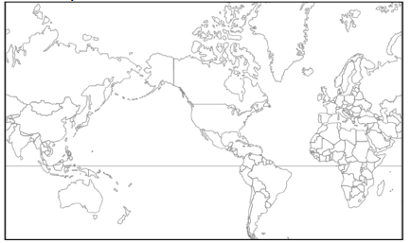

- In Western countries where popular culture predominates, clothing styles generally reflect ________________ rather than particular ________________________.

- How does clothing style (in this case shoes) indicate the influence of the environment on folk culture?

- Can you think of other restrictions on clothing styles in developed countries, perhaps in schools?

- What are three facts about clothing styles associated with popular culture?

- Food preferences are strongly influenced by ______________________________________.

- How can politics influence the spread of popular food preferences?

- List three different examples of food habits and the unique folk cultures each illustrates.

- Indicate some food taboos, along with the cultures that practice them, in the chart below.

Food Taboos
Cultures/Regions | Foods/Reasons

- Do your food preferences match the predominant ones in your region?

- In what sense are building materials of folk housing unique?

- Give three examples of how religious values or belies may influence folk housing.

- Fred Kniffen, a cultural geographer, has identified three source regions for American folk housing styles: New England, Middle Atlantic and Lower Chesapeake. Briefly describe the housing styles he identified with each region.
  - New England –

  - Middle Atlantic –

  - Lower Chesapeake –

Key Issue 4.3: Why is Access to Culture Unequal?
Pages 130-137
- Give two reasons for which television is an especially significant element of culture.

- Using the 2005 map in Figure 4-32 on page 130, complete the following chart about television access
Television is Universal | Television is Common | Television is Rare

- Using the maps on page 131 answer the following questions:
  - In 2017, where was the Internet most widely available?

  - In what regions, then, are there populations still relatively untouched by the Internet?

- What trends do you see regarding the U.S. and the distribution of TV? Of the Internet?

- Briefly describe the diffusion of the three social media platforms.
Facebook-

Instagram-

Twitter-

- What leads some countries to banning certain types of technology?

- Why do developing nations view television as a new source of cultural imperialism?

- How have countries taken action against citizens that attempt to circumvent government restrictions on technology?

- Describe the distribution and types of cyberattacks.

- What is fake news and what are the other practices linked to misinformation?

- What is the purpose of collecting personal data?

Key Issue 4.4: Why Do Cultures Face Sustainability Challenges?
Pages 138-143
- Where did Amish culture originate, and how did it diffuse to the United States?

- What is happening to the Amish in the United States today?

- Label and shade the areas of larger Amish settlements in the U.S. (Use Figure 4-50 on page 138).

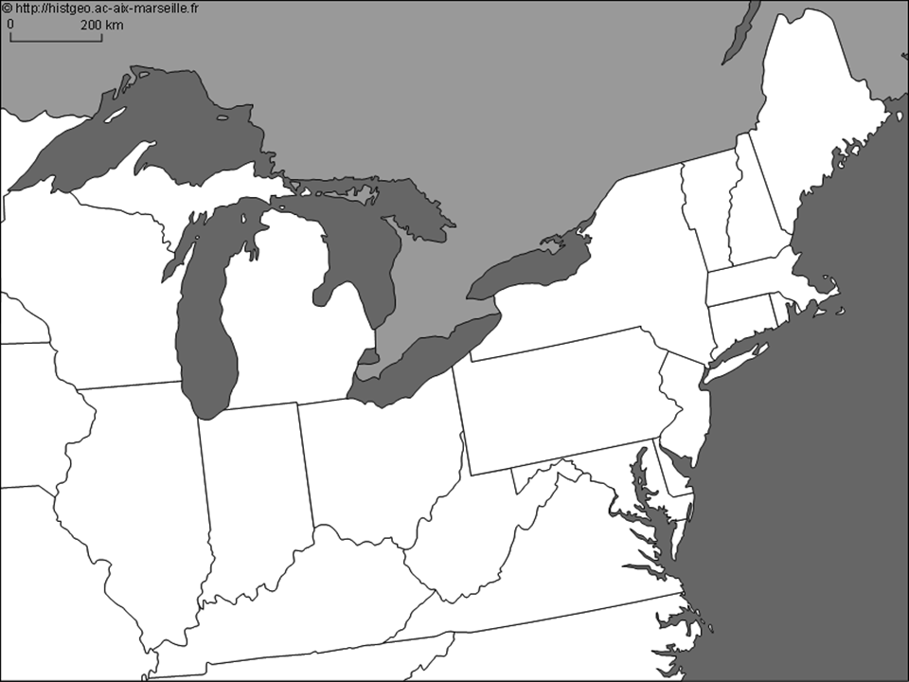
- How has global diffusion of popular social customs had an unintended negative impact on women in India?

- What are the two ways in which popular customs have an adverse effect on the natural environment?

- What is a cultural homogenization?

- How and why is the concept of uniform landscapes utilized by fast-food restaurants?

- How is the playing of golf and golf courses an example of a popular custom that is not generally in harmony with the local environment?

- Provide examples of cultural divergence for each of the following:

Urban-Rural differences:

Cultural Differences Interregional scale:

Cultural Differences Individual scale:

