**Key Issue 1.1: Why is Geography a Science**

***Pages 4-13***

*\*\*\*Always keep your key term packet out whenever you take notes from Rubenstein. As the terms come up in the text, think through the significance of the term.*

1. What is one important way in which history and geography differ?
2. Geographers use two basic concepts to explain why everywhere is unique. Identify and define both:

i.

ii.

1. Geographers use three concepts to explain why locations are interrelated:

i.

ii.

iii.

1. Define ***map:***
2. What are the **two** purposes that maps serve? Explain each.

i.

ii.

1. What is the science of mapmaking called?
2. Who first used the term “geography”? What does the term “geography” mean? (You may have to look it up!)
3. Provide examples of developments in geography for each of the following:

|  |  |
| --- | --- |
| **Chinese** |  |
| **Muslims** |  |
| **Age of Exploration** |  |

1. Geographers use **GIS** (Geographic Information System) to store “layers” of data. Give **four** types of data stored in a single layer.
2. Define ***remote sensing:***
3. List several things that geographers can map using remotely sensed data.
4. Complete the following regarding a ***Global Positioning System***

|  |  |
| --- | --- |
| Elements/Components | Uses/Implementation |
|  |  |

1. Explain a ***mashup*** in relation to geography and GIS.
2. Define ***map*** ***scale:***
   1. List the three types of map scale with an example for each one.
   2. What is the advantage of a map which shows only a small portion of the earth’s surface – like a neighborhood – that is, a ***large-scale map***?
   3. What advantage does a map which shows the entire globe, a ***small-scale map***, have?
3. When geographers convert the round Earth to a flat map, they use a **projection.** All projections have some distortion (only a globe has none). List the **four** things that typically become distorted in various projections and explain the distortion.
4. Two important projections are the **Mercator** and the **Winkel.** Complete the chart below to compare their advantages and disadvantages (use figures 1-17 & 18).

|  |  |  |
| --- | --- | --- |
|  | **Mercator** | **Winkel** |
| **Advantages** |  |  |
| **Disadvantages** |  |  |

1. What place is designated as 0 degrees longitude?
2. What is the name for the line drawn at 0 degrees longitude?
3. What is the name for the line drawn at 0 degrees latitude?
4. How is a degree of longitude or latitude further subdivided?
   1. Give an example.
5. How many degrees of longitude do you need to travel across to pass through one “hour” of time (or one time zone)?
6. How many time zones are there?
7. Using an outside source, find out which country first adopted time zones and when that occurred.
8. What is the longitude of the International Date Line?
9. Use page 11 and the information in the reading to annotate the map below.
   1. Draw the **Prime Meridian** and **International Date Line.**
   2. Label the country that moved the International Date Line in 1997.

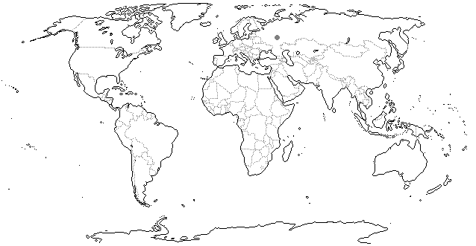

**Key Issue 1.2: Why Is Every Place Unique?**

***Pages 14-19***

1. What are the three ways geographers identify location?
2. Define ***toponym:***
3. Identify **four** ways in which places can receive names
4. Define ***site:***
5. List some ***site characteristics:***
6. Describe the site for Daytona beach:
7. Complete the following sentence about site:
   1. Human have the ability to ______________________________ the characteristics of a site.
8. Define ***situation:***
9. What role do familiar places have in understanding **situation** of unfamiliar places?
10. How can the situation of a place increase its importance?
11. What characteristics help identify a ***region***
12. Define ***cultural landscape***?
13. How did geographer Carl Sauer define cultural landscape?
14. Complete the chart below which details types of regions identified by geographers:

|  |  |  |  |
| --- | --- | --- | --- |
|  | **Formal Region** | **Functional Region** | **Vernacular Region** |
| Also Called |  |  |  |
| Definition |  |  |  |
| Example |  |  |  |

1. What **two** meanings of culture do geographers study?
2. Geographers place great importance on the cultural values derived from language, religion, and ethnicity. Describe below how each of these traits identify the location and values of the culture.
3. What can geographers learn by examining the material wealth of a culture?
4. How does a geographer conclude that two (or more) phenomena are “spatially associated,” that is, that they bear some sort of cause and effect relationship?

**Key Issue 1.3: Why Are Different Places Similar?**

***Pages 20-33***

1. Define ***globalization:***
2. In what ways is globalization of culture changing the landscape? Provide an example.
3. In what ways has the **communications revolution** played a role in globalization?
4. What impact have transnational corporations had on local economies?
5. Why might some group(s) of people oppose globalism or globalization?
6. The __________________________ of a feature in ______________________ is known as its **distribution.**
7. Define ***density:***
8. In the boxes below, draw 10 dots in each so that the density is the same in each, but illustrate and label the two different kinds of concentration.

|  |  |
| --- | --- |
|  |  |

1. List the two different types of **pattern** given in the text.
2. What affects has electronic communication had on human interactions?
3. Identify the three different types of geographic thought and provide examples for each.

|  |  |  |
| --- | --- | --- |
| **Geographic approach** | **Description of its emphasis** | **example** |
|  |  |  |
|  |  |  |
|  |  |  |

1. How is **uneven development** demonstrated within the areas know as **core and periphery**?
2. How has income inequality changed in the U.S. since 1979? How has that been mapped?
3. Describe the difference between **sex** and **gender**?
4. How do gender roles impact spatial patterns?
5. Provide information on the issues of distribution that geographers examine for each of the topics.

|  |  |  |
| --- | --- | --- |
| **Gender** | **Sexual Orientation** | **Ethnicity & Race** |
|  |  |  |

1. ***Diffusion*** is defined as the process by which a characteristic spreads across space. With regard to diffusion, define and, where possible, give an example of each of the following:

|  |  |  |
| --- | --- | --- |
|  | **Diffusion** | |
|  | **Hearth** |  |
|  | **Relocation Diffusion** |  |
|  | **Hierarchical Diffusion** |  |
| **Expansion**  **Diffusion** | **Contagious Diffusion** |  |
|  | **Stimulus Diffusion** |  |

1. Describe the phenomenon known as **distance decay**.
2. What is **space-time compression?**
3. How has interaction between places changed? (think **networks**)
4. In the past, most interaction between places required what?
5. Identify and define the three possible results from connections between cultural groups.

|  |  |  |
| --- | --- | --- |
| **Assimilation** | **Acculturation** | **Syncretism** |
|  |  |  |

1. How have modern networks impacted the world?

**Key Issue 1.4: Why Are Some Actions Not Sustainable?**

***Pages 34-42***

1. Define ***sustainability:***
2. Explain the difference between **renewable resources** and **nonrenewable resources.**
3. What are the **two** major misuses of resources geographers observe?
4. In the table below, explain and give a bulleted list of details (summarize info) about each of the **pillars of sustainability**

|  |  |
| --- | --- |
| **3 Pillars of Sustainability** | |
| **Environment** *(focus on* ***conservation*** *vs.* ***preservation****)* |  |
| **Social** |  |
| **Economic** |  |

1. Explain **two** major criticisms about sustainability
2. What are the types of **climates** geographers identify? (by letter and name)
3. In what major way does climate influence human activities? (Give an example)
4. What is the hydrosphere and what impact could it have on geography?
5. What is the lithosphere and why might geographers study it?
6. Why are human geographers interested in ecosystems involving interaction of humans with the biosphere and abiotic spheres?
   1. For example- soil: What are the **two** major problems with which geographers are concerned as far as soil is concerned?
7. Very carefully define the following terms:
   1. ***Cultural Ecology***
   2. ***Environmental determinism***

* 1. ***Possibilism***

1. Complete the two case studies below using pages 40-41 which describe human modifications of and adaptations to the local environment. To do so, annotate the blank maps and bullet in brief notes to the right of each (this means label/shade the map to reflect what is happening and right notes next to the map of each)
   1. **The Netherlands**



* 1. **Cape Town, South Africa**

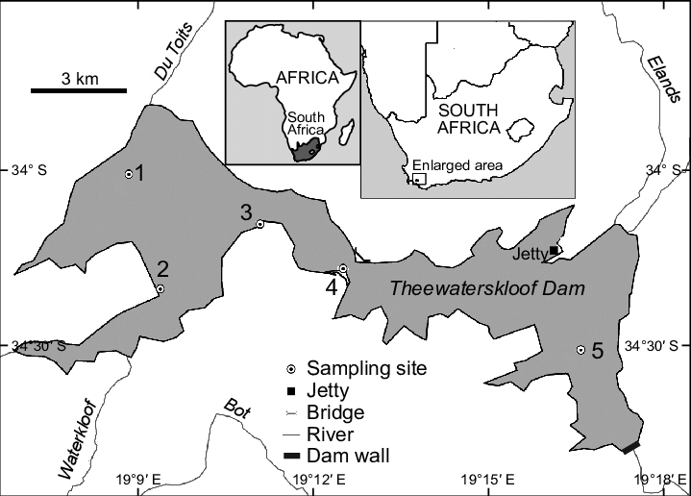

1. How many time zones are there? How many degrees of longitude per hour?
2. What is the function of the International Date Line?
3. Why do many time zone lines not run straight (look at the map on page 42)?