Key Issue 11.1: Where Is Industry Distributed?
Pages 388-399 ***Always keep your key term packet out whenever you take notes from Rubenstein. As the terms come up in the text, think through the significance of the term.
- Regarding the Industrial Revolution: What? Where? When?

- Define cottage industry:

- How did the iron industry benefits from the steam engine?

- Why did the textile industry shift to factories?

- How did the Industrial Revolution and factory system contribute to the need for food processing?

- What two forms of transportation grew rapidly and why were they necessary?

- As you read the section, make notes on the resources, advantages, conditions, and issues in each of the sub regions of industrial development discussed. Shade and label each of the regions on the maps. (Use maps on pages 390-391 as guides)
Europe

United Kingdom – | Rhine-Ruhr -
Mid-Rhine – | Po Basin -
Northeastern Spain – | Moscow -
St. Petersburg – | Urals –
Volga - | Kuznetsk -
Donetsk – | Silesia -
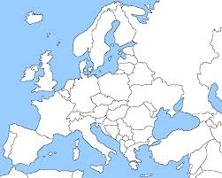

North America

New England – | Middle Atlantic -
Mohawk Valley – | Pittsburgh-Lake Erie -
Western Great Lakes – | Northern California-
Southeastern Ontario – | Southern California -
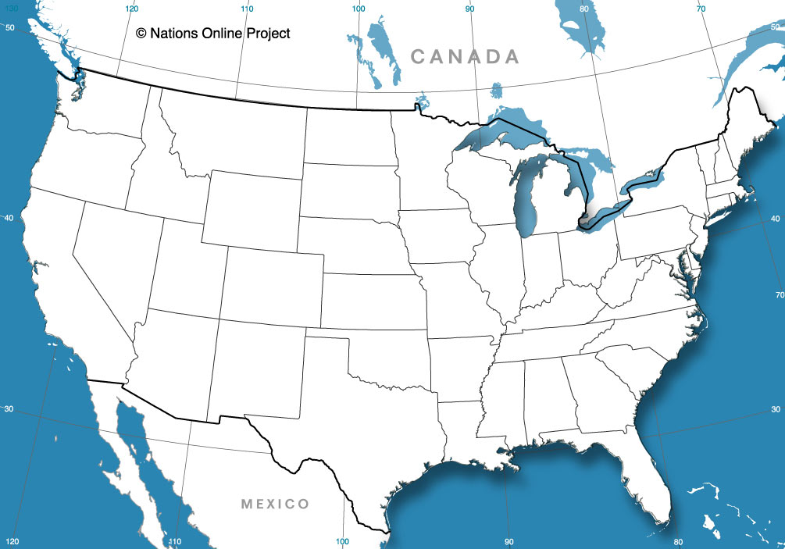
East Asia
Japan – | China -
South Korea –

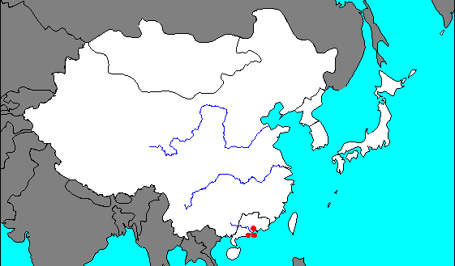

- Define site factors:

- What are the three production cost factors associated with the site of an industry? (Memorize Them!)

- Define labor intensive industry:

- Explain the difference between “labor-intensive”, “capital-intensive”, and “high-wage” industries.

- What factors influence industry to remain in northeast U.S. or northwest Europe?

- Define Fordist & Post-Fordist production:

- Describe the relationship between capital and the computer industry in California.

- What are several factors about a given piece of land that make it attractive to industry and manufacturing?

- Define situation factors:

- Define the following terms-
Proximity to inputs- Proximity to markets-

- What is a “bulk-reducing industry”?

- Make a brief flow chart to illustrate how copper is an example of a bulk-reducing industry.
Step 1 >>>>>> Step 2 >>>>>> Step 3 >>>>>> Step 4 >>>>> Step 5

- What is a “bulk-gaining industry”?

- Give two examples of these industries, and explain how they are bulk-gaining.

- Specialized manufacturers make products that are designed to be sold primarily to
_____________________________________________________.

- Where is their optimum location?

- Describe one example of this phenomenon.

- List examples of “perishable products” that must be located near their markets.

- Explain how motor vehicle production is a bulk-gaining industry.

- Where are the three regions of assembly plants for vehicle production?

- Give reasons for why each of the following modes of transportation might be selected by a manufacturer to deliver their products to market.

TRUCKS
TRAINS
Air
SHIPS

- What is a “break-of-bulk point”?

- Give two examples of important break-of-bulk points.

- What is the benefit of containerization?

- What benefits do the manufacturers receive from just-in-time delivery?

- What are the disruptions that can result from this method?

Key Issue 11.2: Why Do Industries Face Energy Challenges?
Pages 400-413
- Define supply:

- Define demand:

- What are fossil fuels?

- Describe the four principle types of consumption of coal, petroleum, and natural gas (pg. 401).

- Fill out the following table using the text pages 400-405
Resource | What is it? | Where is it? | Proven Reserves
Coal
Petroleum
Natural Gas
- What is OPEC?

- Explain the two ways potential reserves can become proven reserves

- Describe two ways demand for petroleum has been reduced.
*

*

- Describe two examples of unconventional fossil fuel resources.
*

*

- Discuss the advantages and disadvantages of using nuclear energy as an alternative energy source.
Distribution-

Potential Accidents-

Radioactive waste-

Bomb material-

Limited reserves-

High cost-

- Create a bulleted list of key information for each of the following types of renewable energy in the table below
Renewable Energy | Key Details
Biomass Fuel
Hydroelectric
Wind Power
Geothermal Energy
Passive Solar Energy
Active Solar Energy

Key Issue 11.3: Why Do Industries Face Pollution Challenges?
Pages 414-421
Bullet key information for each sub section for each of the three types of pollution geographers worry about. Describe key vocabulary terms and how they apply.
Air Pollution
Local Scale
Regional Scale
Global Scale

Water Pollution
Demand for water
Impact on Aquatic life
Sources
Solid Waste Pollution
Sanitary Landfill
Hazardous Waste

9. What are the four main ways that materials are collected for recycling?

10. Describe each of the four principal inputs in remanufacturing.
*

*

*

*

Key Issue 11.4: Why Are Industries Changing Locations?
Pages 422-429
- Why do transnational corporations transfer work to developing countries?

- What is the new international division of labor?

- Define outsourcing:

- Provide an example of an industry that outsources, and what do they outsource?

- Define maquiladoras:

- Explain the two major fears of the integration of a North American industry.

- Who are the five BRICS countries and what are they expected to do?

- What is the primary site factor for production of textiles?

- What country accounts for most of the world’s spinning and weaving?

- Why do MDCs play a larger role in textile assembly than LDCs?

- What situation factors have changed for the steel industry?

- Why do we see a change in production of steel globally?

Use Figure 11-87 on page 427 to describe the changing location of steel mills in the U.S. Explain when and why each location was preferred.
- Pittsburgh, southwestern Pennsylvania

- Locations around southern shore of Lake Erie

- Southern Lake Michigan (Gary, Indiana & Chicago)

- East and West Coasts (Trenton, NJ & Los Angeles, CA)

- Why are the newest steel mills (minimills) beginning to move closer to markets and away from inputs?

- How are manufacturing jobs shifting in the U.S.?

- Define right-to-work laws:

- Why are southern right to work states attractive to companies?

- Why have manufacturing locations changed in Europe?

